Day 3 — Lab 1: Use Case 7 — AI Video Generation Workflow with Sora 2
Duration: 90–120 minutes · Windows · VS Code · Python 3.11+ · Microsoft Foundry

1. Objective
Build an end-to-end video-generation workflow using Sora 2. Participants will enter a prompt in the terminal, submit a generation request, monitor the job, download the generated MP4, and validate the execution metadata.

2. Prerequisites
- Microsoft Foundry access and an available Sora 2 deployment.
- Resource endpoint, API key, and deployment name.
- Python 3.11+ and VS Code.
- The corrected generate_video.py script.
Authentication: Use the API key and endpoint from .env.

3. Step-by-step implementation

Step 1 — Open the lab project
Open VS Code and load the existing project folder:
C:\Day3-UseCase7-Sora2
Open the integrated PowerShell terminal and navigate to the folder:
cd C:\Day3-UseCase7-Sora2

Step 3 — Create the virtual environment if needed
python -m venv .venv

Step 4 — Activate the environment
.\.venv\Scripts\Activate.ps1
Confirm that (.venv) appears in the terminal prompt.

Step 5 — Install dependencies

python -m pip install --upgrade openai azure-identity pip

python -m pip install -r requirements.txt

Step 6 — Configure .env
Open .env and verify these values against the deployed Sora 2 resource.
AZURE_OPENAI_ENDPOINT=https://YOUR-RESOURCE-ENDPOINT
AZURE_OPENAI_API_KEY=YOUR_RESOURCE_API_KEY
AZURE_OPENAI_DEPLOYMENT_NAME=YOUR_SORA_DEPLOYMENT
Save the file. Do not share the API key or commit .env to source control.

Step 7 — Verify the project files
Confirm that the project contains:
Day3-UseCase7-Sora2/
├── .env
├── .gitignore
├── generate_video.py
├── requirements.txt
└── output/
Ensure generate_video.py contains your corrected video-generation implementation.

Step 8 — Execute the workflow
Run:
python generate_video.py
When prompted, enter the following sample video prompt:
Create a four-second cinematic advertisement featuring premium wireless headphones rotating slowly on a minimalist studio pedestal. Use soft blue lighting, realistic materials, a smooth camera push-in, and a clean dark background. No text, logos, or people.
Press Enter to submit the request.
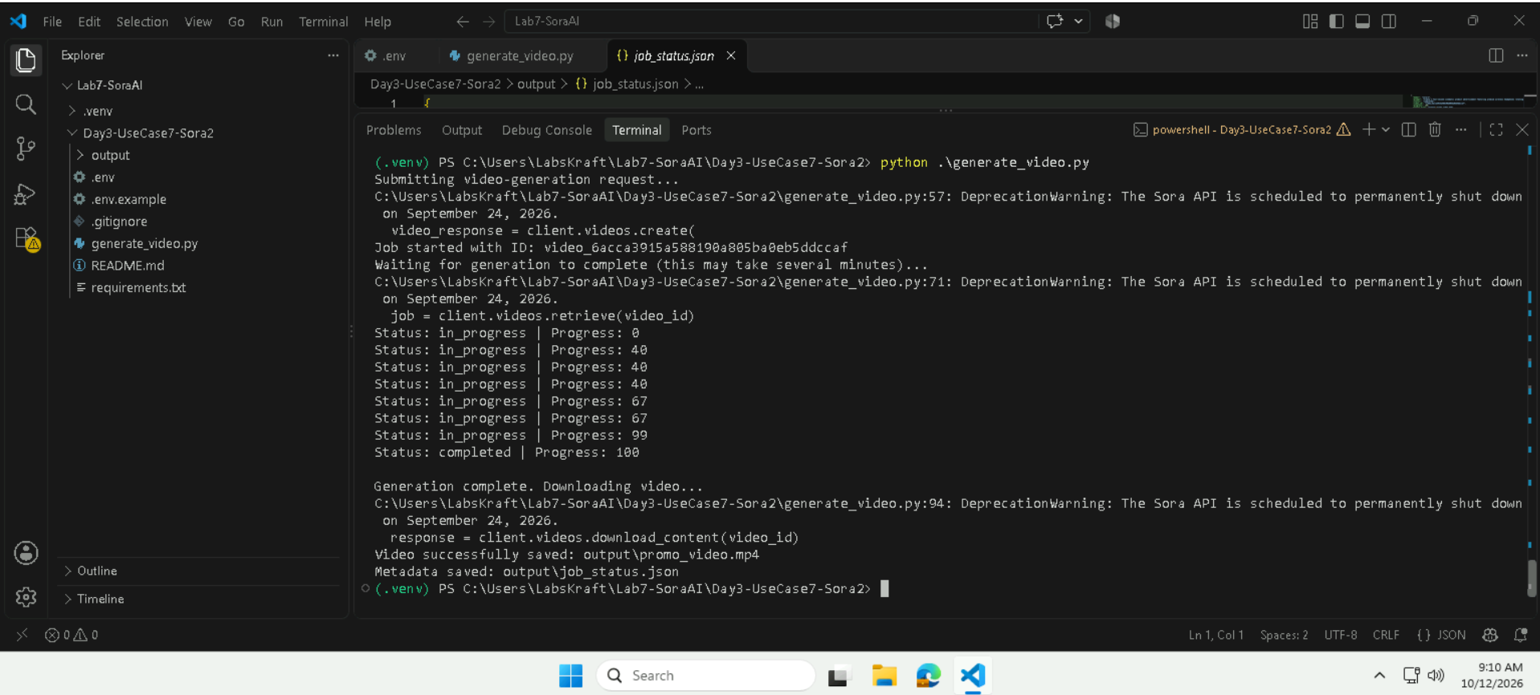

Step 9 — Monitor video generation
Observe the terminal output for:
- Request submission.
- Video job ID.
- Job status updates.
- Successful completion.
- Video download confirmation.
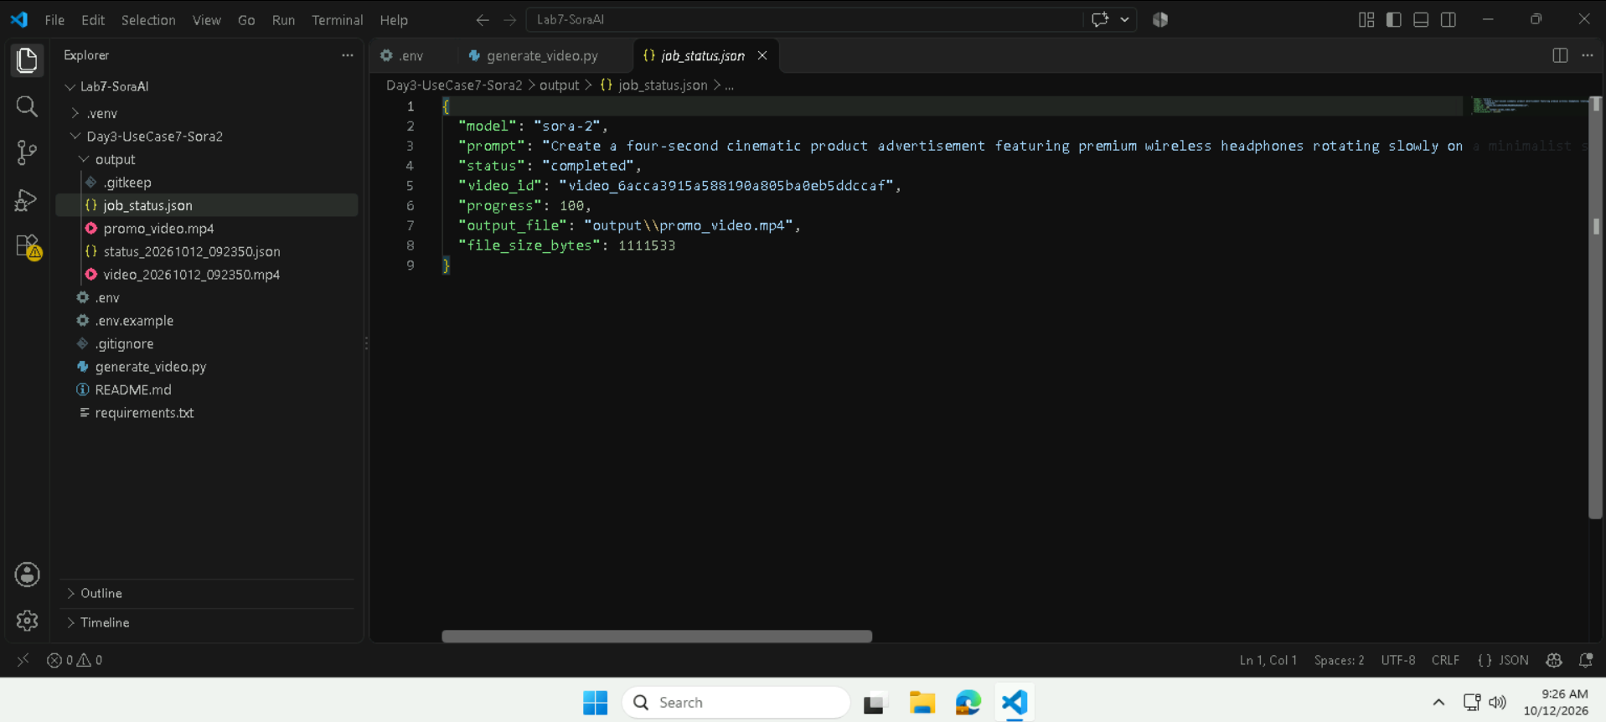Allow the service to finish processing. Video-generation time depends on model availability and service load.

Step 10 — Validate the output
Run:
Get-ChildItem .\output
Confirm that the generated MP4 and job metadata JSON are present. Their filenames should match those defined in your corrected script.
Open the MP4 in a media player and verify that it plays. Open the JSON file in VS Code and inspect the job ID, prompt, final status, and output details.

Step 11 — Test another prompt
Run the script again:
python generate_video.py
Enter a different prompt, such as
A cinematic wide shot of a lone astronaut walking across a dusty red planet under a sky with two moons. Soft golden hour lighting casts long shadows. The camera slowly pans left to match their walking pace. The audio features heavy, rhythmic breathing and ambient wind sounds
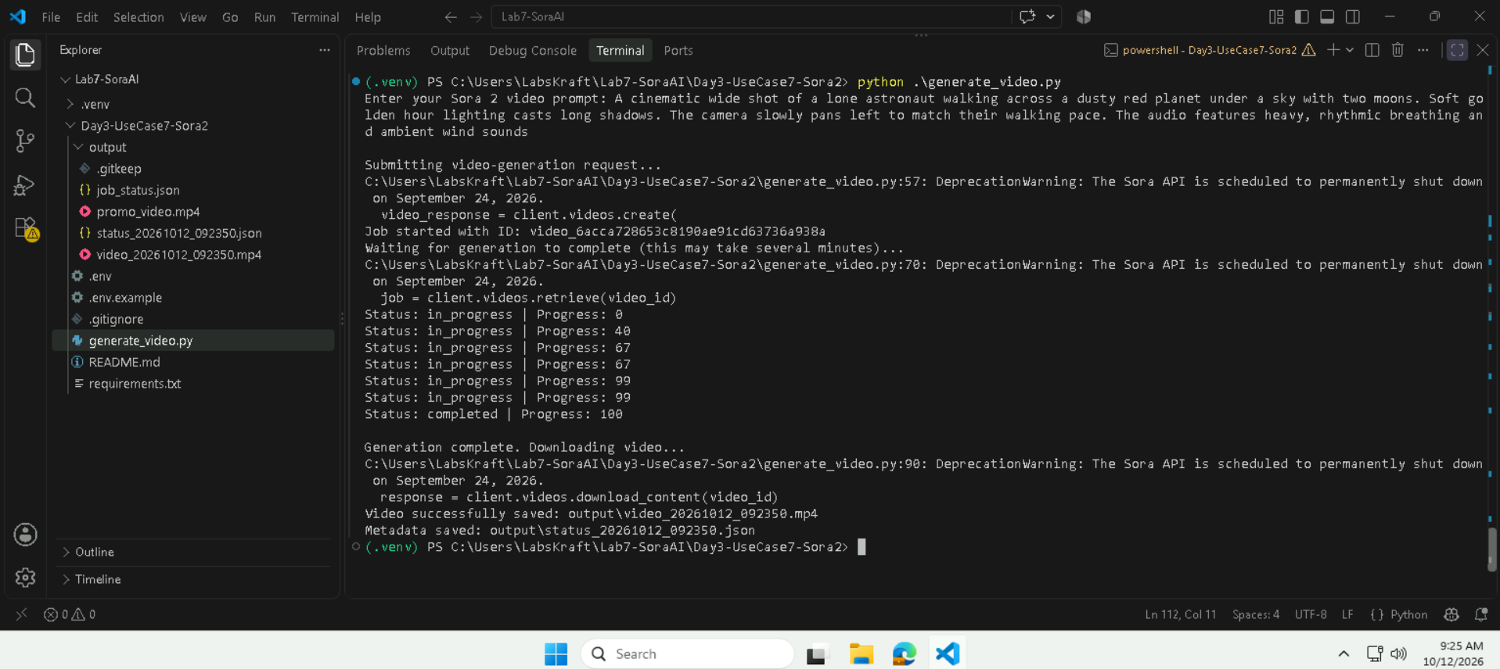

4. Validation / Expected output
Validation | Expected result
Configuration | Endpoint, API key, and deployment are loaded
Authentication | API request is accepted
Submission | Job ID is returned
Monitoring | Job reaches a successful terminal state
Download | Generated MP4 is saved
Metadata | JSON records the execution details
Prompt variation | A second prompt can produce another video

5. Cleanup
- Retain the generated video and JSON if needed for assessment.
- Remove temporary output when no longer required.
- Keep API keys private.
- Do not delete the shared Foundry resource or deployment.
- Deactivate the environment when finished: deactivate

